Department Of Campus
Name : U Zaw Naing Tun
Rank : Security(2)
Degre : G(11)
Phone : 09-401593457
e-mail address :

Department
Name : U Ye Naing Myint
Rank : Security(4)
Degre : B.A(gro)
Phone : 09-456060502
e-mail address :



Name : U Myint Zaw Aye
Rank : Machinist(4)
Degre : G(10)
Phone : 09-265406560
e-mail address :


Name : U Nay Min Tun
Rank : JAMADA
Degre : G(10)
Phone : 09-454050643
e-mail address :

Name : U Si Thu Shein
Rank : Machinist(5)
Degre : G(10)
Phone : 09-420177303
e-mail address :


Name : U Win Aung
Rank : Security(5)
Degre : G(5)
Phone : 09-684095026
e-mail address :
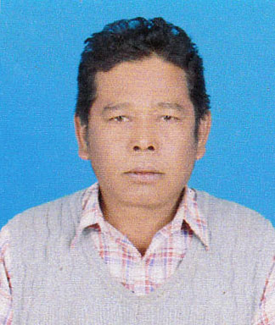


Name : U Nay Myo Oo
Rank : Security(5)
Degre :
Phone : 09-447334632
e-mail address :

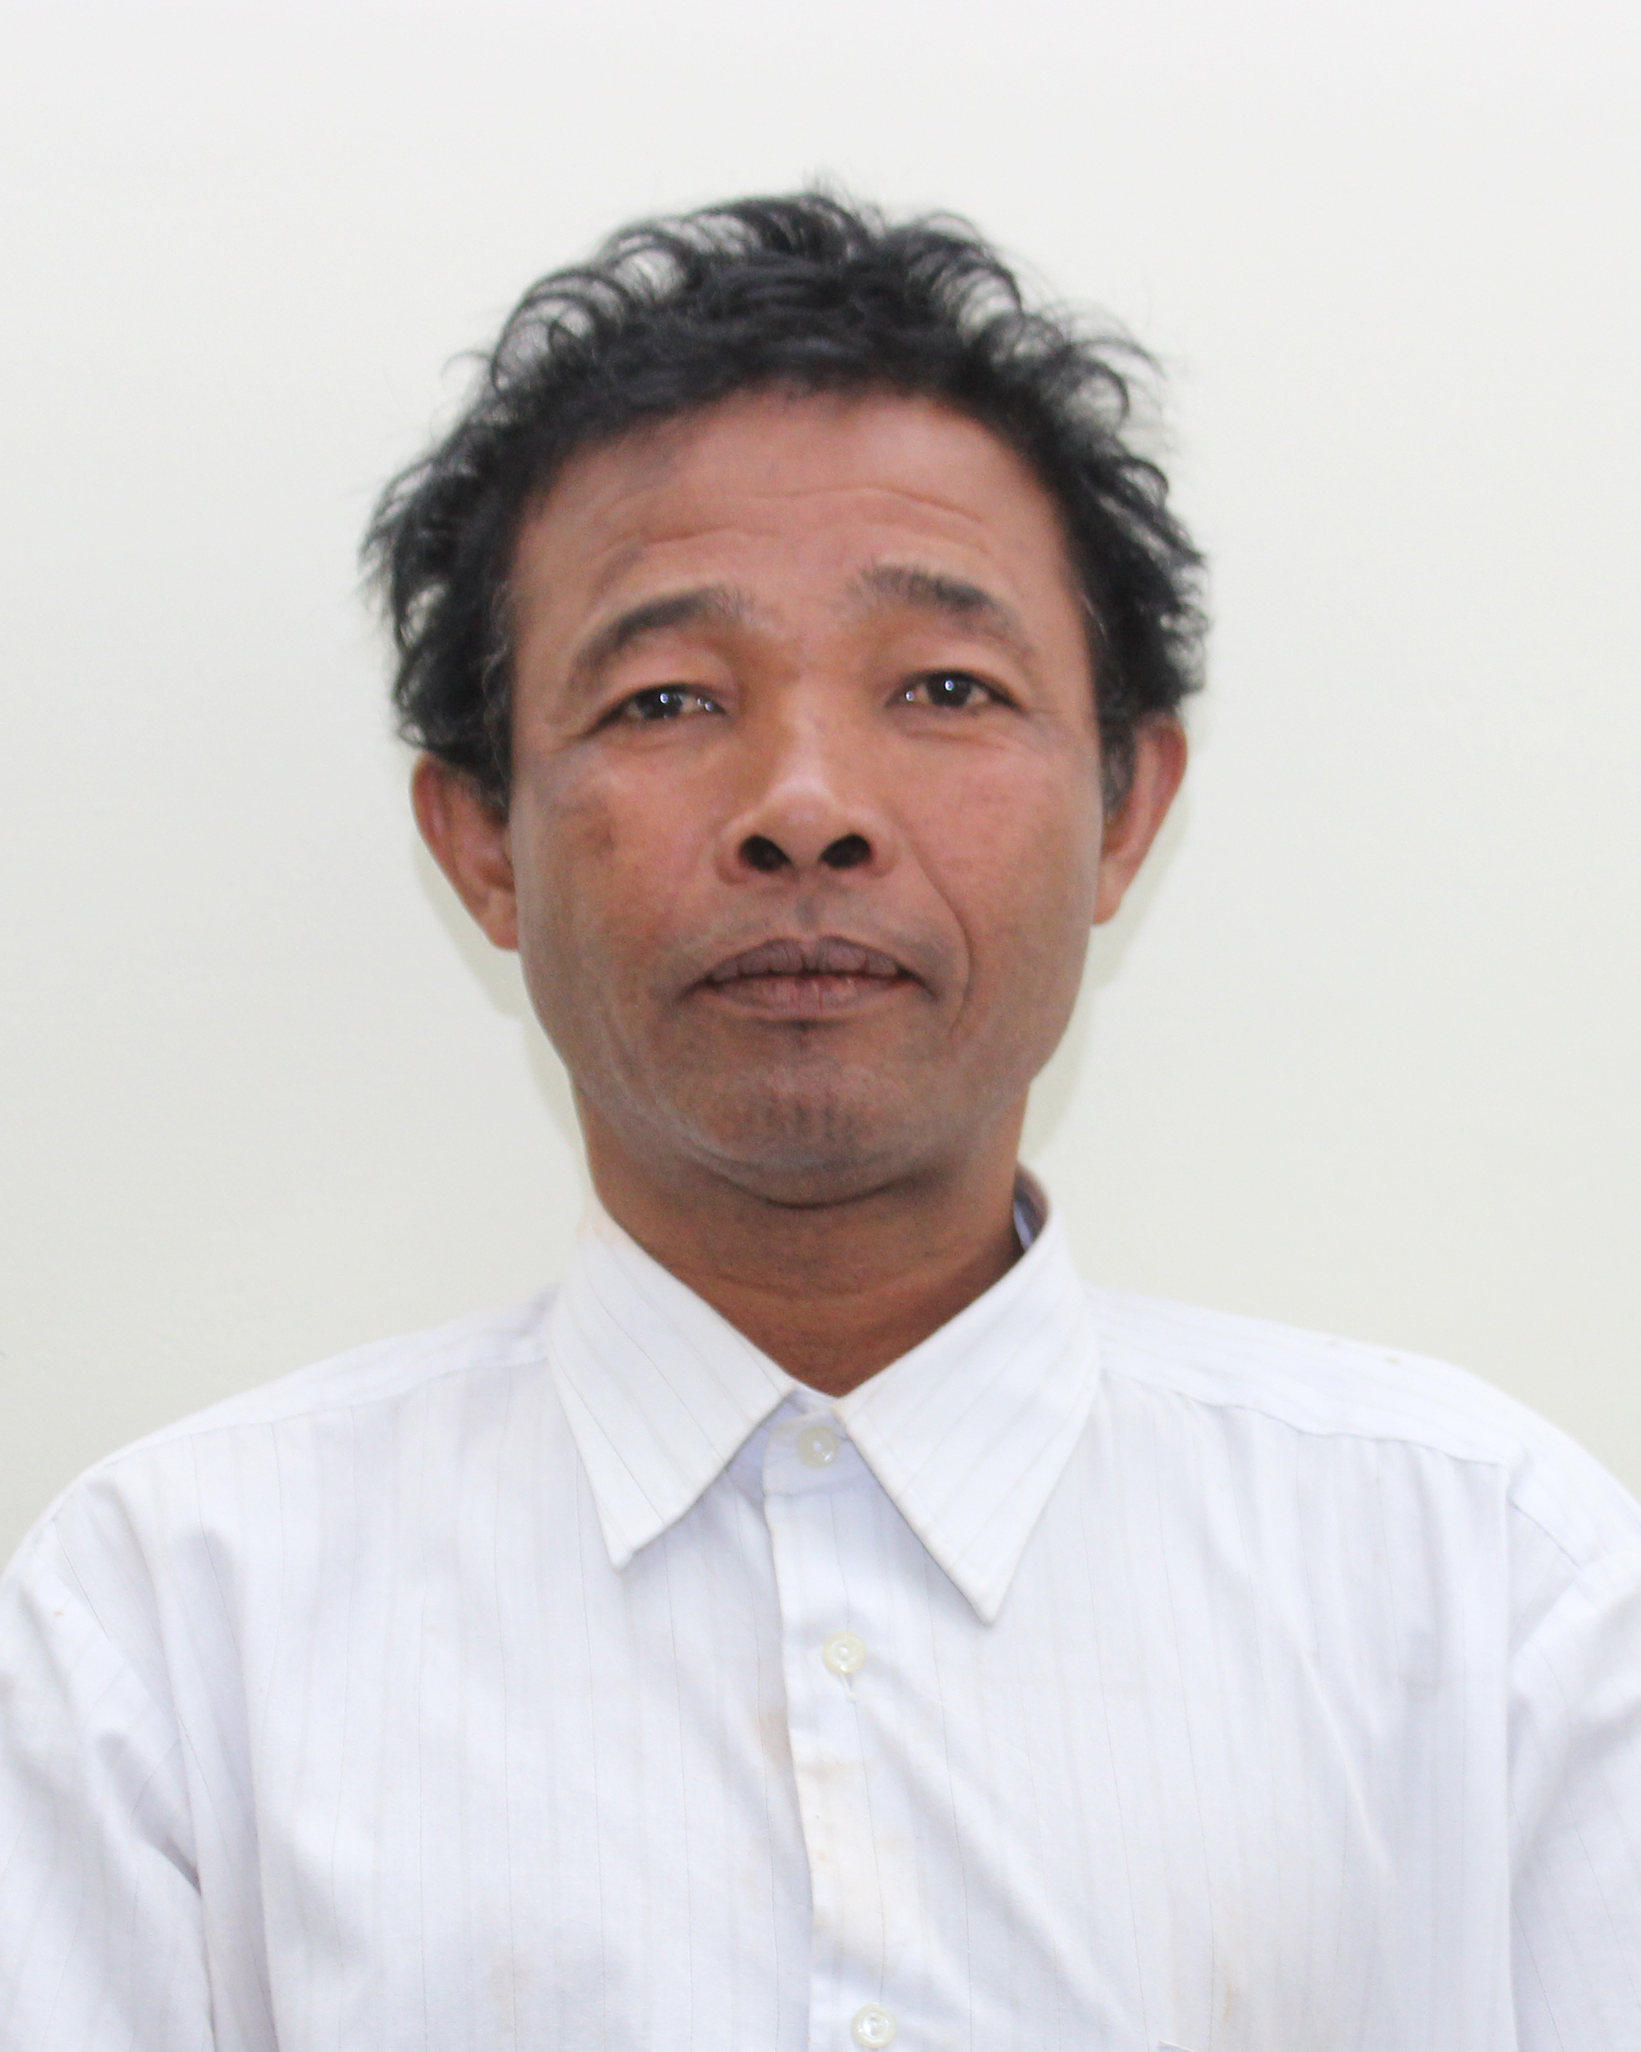
Name : U Htein Lin
Rank : Security (5)
Degre : G(6)
Phone : 09-252786282
e-mail address :


Name : Daw Thwe Thwe Khaing
Rank : Garden Work
Degre : G(9)
Phone : 09-400642397
e-mail address :


Name : Daw Phyu Sin Kyaw
Rank : Garden Work
Degre : G(9)
Phone : 09-764820529
e-mail address :


Name : Daw Moe Moe Kyi
Rank : General
Degree : G(9)
Phone : 09-426857469
Emai address :

Name : U Tin Min Aung
Rank : Machinist(5)
Degre : G(9)
Phone : 09-256027945
e-mail address :
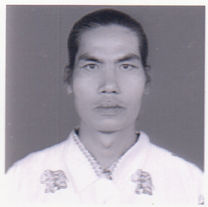
Name : U Hlaing Win Maung
Rank : Lower Division Clerk
Degree : B.A (History)
Phone : 09-32730332
Email :
Name : U Hlaing Win Maung
Rank : Lower Division Clerk
Degree : B.A (History)
Phone : 09-32730332
Email :


Name : U Kyaw Kyaw
Rank : Security(5)
Degre : G(9)
Phone : 09-898813887
e-mail address :
Name : U Hlaing Win Maung
Rank : Lower Division Clerk
Degree : B.A (History)
Phone : 09-32730332
Email :
Name : U Hlaing Win Maung
Rank : Lower Division Clerk
Degree : B.A (History)
Phone : 09-32730332
Email :


Name : U Htet Wai Yan
Rank : Security
Degre : G(10)
Phone : 09-452768636
e-mail address :


Name : U Than Htun Naing
Rank : Security
Degre : G(11)
Phone : 09-252786282
e-mail address :

Name : U Pyae Phyo Aung
Rank : Security
Degre : G(10)
Phone : 09-673047379
e-mail address :



Name : U Moe Min Win
Rank : Securityy
Degre :
Phone : 09-794050752
e-mail address :

Name : U Soe Moe Hlaing
Rank : Security
Degre : G(10)
Phone : 09-783629113
e-mail address :
